BODYOGRAPHY
Wellness Center

Office Use Only:

fc:

rb:

Client Intake Form

Today’s Date:_______________________

Name:_____________________________________________ Preferred pronouns:__________________
Address:___________________________________________ Home Phone:_______________________
City, State, Zip Code:_________________________________ Cell Phone:_________________________
Email address:_______________________________________ Work Phone:_______________________
DOB:___________ Occupation:________________________ Height:________ Weight:_________
Email? Yes No US Mail? Yes No How did you hear about us?_______________________
In case of emergency, please notify:
Name:______________________________ Relation:__________________ Phone:__________________

Current Condition/Medical History:

Have you ever received massage or other bodywork before? Yes No
If yes, what type?_________________________________ How often?____________________

What are your goals for receiving massage?_______________________________________

Please rate the stress level in your life (5 is the most) 1 2 3 4 5

Please list all of your major complaints: Date of onset:
_______________________________________________________ _________________________
_______________________________________________________ _________________________
_______________________________________________________ _________________________

Are you currently under the care of a medical doctor/health practitioner? Yes No
If yes, for what condition?___________________________________________________________________
Health practitioner’s name & phone number:____________________________________________________

Please list all the medications/supplements you currently take, including dosage:
_________________________ _________________________ __________________________
_________________________ _________________________ __________________________
_________________________ _________________________ __________________________

Please list any accidents/surgeries you have had: Date:
__________________________________________________________ ________________
__________________________________________________________ ________________
__________________________________________________________ ________________
Have you had orthodontic work: Yes No Dentures? Yes No
Do you wear contact lenses? Yes No Do you smoke? Yes No
Do you exercise? Please describe:___________________________________________________________
________________________________________________________________________________________
(please turn over)
Please check if you have/had any of the following:
___Allergies ___Arthritis ___Asthma ___Back pain
___Bursitis ___Cancer ___Car accident ___Carpal Tunnel
___Chest pains ___Circulatory problems ___Dislocations ___Decreased range of motion
___Diabetes ___Digestive disorders ___Dizziness ___Edema
___Fatigue ___Fibromyalgia ___Fractures ___Fainting spells
___Gout ___Headaches ___Heart conditions ___Herniated discs
___HIV/AIDS ___Insomnia ___Loss of balance ___Low/High blood pressure
___Muscle sprain ___Neck pain ___Nerve damage ___Pins/needles
___Pacemaker ___Pregnant now ___Respiratory problems ___Sciatica
___Seizures ___Shortness of breath ___Sinusitis ___Skin problems
___Spinal disorders ___Sport injury ___Stress ___Surgeries
___Tendonitis ___TMJ ___Ulcers ___Varicose veins

Any other medical conditions:_________________________________________________________________
_________________________________________________________________________________________
_________________________________________________________________________________________

Please indicate any areas of joint or muscle pain on the figures below:

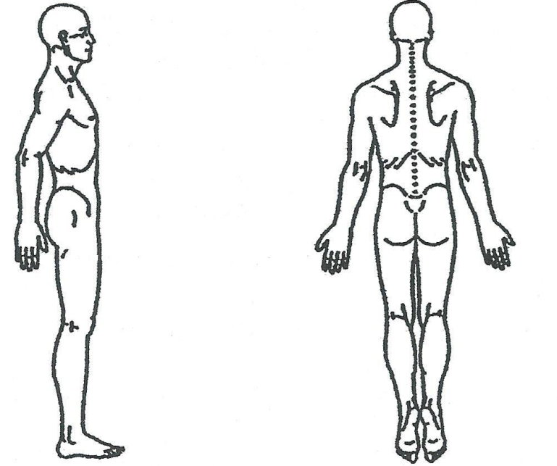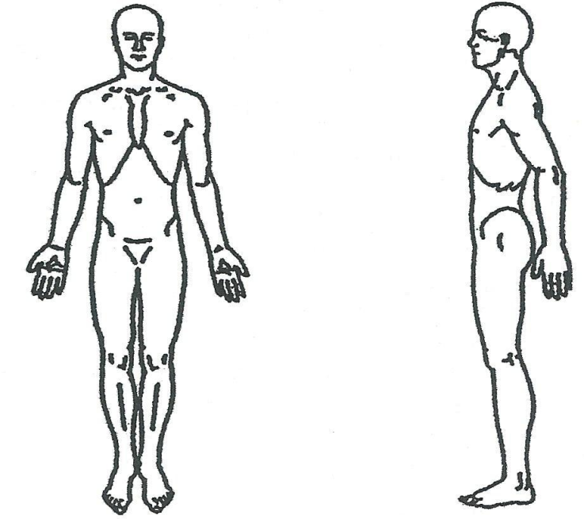

Waiver/Informed Consent:
I, ____________________________________, understand that the massage therapy provided by Bodyography Wellness Center, LLC is intended to enhance relaxation, release muscle tension or spasm, increase range of motion, or improve circulation or energy flow. I understand the massage therapist does not diagnose illness or disease, does not prescribe medications, and does not perform spinal manipulations. I understand that massage therapy is not a substitute for medical treatment or medications and that it is recommended I see a physician for any ailment I may have. I have informed the massage therapist of all my known physical conditions, medical conditions, and medications. I will keep the massage therapist updated on any changes. In situations where a physician’s medical release is requested by Bodyography Wellness Center, LLC and the client refuses and/or is unable to provide it, the client shall take full responsibility for any loss, injury, or damages. Twenty-four (24) hour notice of cancellation is required or I agree to pay the full cost of the session scheduled.

Signature:_________________________________________ Print Name:___________________________

Therapist Signature:_____________________________________ Date:________________________

